INDIAN SCHOOL AL WADI AL KABIR
UNIT TEST (2022 - 23)
Class: XII Sub: PHYSICS (042) Max Marks: 30
Date: 31.05.2022 Set - 2 Time : 1 hour
---------------------------------------------------------------------------------------
General instructions;
- All questions are compulsory. There are 10 questions in all.
- This question paper has 3 sections. section A, section B and section C.
- Section A contains 2 questions each carries 2 marks, section B contains 7 questions
3 marks each. section C contains a case study with 5 mcqs 1 mark each.
- There is no overall choice. Internal choice is provided 1 in section A and 1 in section B.
SECTION A (2 x 2 = 4)
1. (a)Define the term electric dipole moment. Is it a scalar or vector quantity?
(b)What is an ideal (point) dipole?

2. The energy of a capacitor varying with its capacitance is shown by two graphs: (i) and (ii). Which of the graphs (a) charge is constant, and (b) potential difference is constant? Give reason in support.

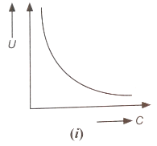
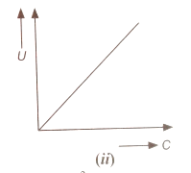

OR
Vehicles carrying inflammable materials usually have metallic ropes touching the ground during motion. Why?
SECTION-B (7 x 3 = 21)
3. Derive an expression for torque on a dipole placed in uniform electric field at an angle ‘θ’ and conditions for maximum and minimum torque.

4. Calculate the equivalent capacitance between the points A and B of the
circuit given below. Find the equivalent capacitor. If a battery of EMF 10 volt is connected
between the points A and B, calculate the total charge in the circuit.

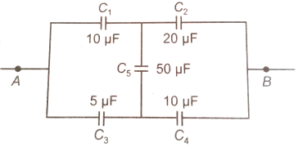

5. Two identical point charges Q are kept at a distance ‘r’ from each other.
A third point charges placed in the line joining of two charges such that
all three charges are in equilibrium. Find the magnitude, sign and
position of the third charge?

6. Uniformly charged conducting sphere of 2.5 m in diameter has a
surface charge density of 100 µC/m². Calculate the (i) charge on the sphere, and (ii)total
electric flux passing through the sphere.

7. Two isolated metal spheres A and B have radii R and 2R respectively
and same charge ‘q’. Find which of the two spheres have greater
(i) capacitance, and (ii) energy density just outside the surface of the spheres

8. Deduce an expression for the electric field at a point on the equatorial plane of an electric dipole of length ‘2a’.
OR
Two infinitely large plane thin parallel sheets having surface charge
density σ₁ and σ₂ (σ₁ > σ₂) are shown in the figure. Write the magnitude
and direction of the net field in the regions marked I, II and III.

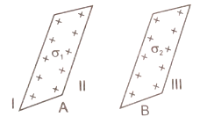
9. Define equipotential surface. Find its orientation with respect to electric field. Draw equipotential surface for (i) a point positive charge and (ii) an electric dipole.

SECTION-C ( 5 x 1 = 5)
10. Read the paragraph carefully and answer the following questions.

ELECTROSTATIC SHIELDING:
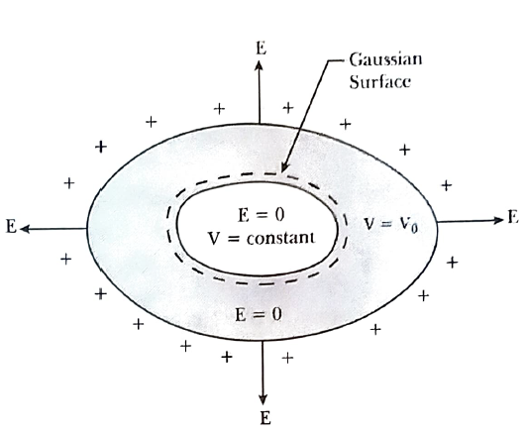
The phenomenon of making a region free from any electric field is called electrostatic shielding or electrostatic screening. It is based on the fact that electric field becomes zero inside the cavity of hollow conductor. In the hollow conductor charges are distributed on the surface of conductor. Such a field free region is also called a Faraday cage. Such a cage can block the effects of an external field on its internal contents, or the effects of an internal field on the outside environment. Inside the Faraday cage, electric field is always zero. Even if the conductor is charged or charges are induced on a neutral conductor by an external field, all changes reside only on the outer surface of the conductor. Hence, any cavity of any shape and size is always shielded from outer electric field region.

(i) In a region of constant potential
(a) the electric field is uniform
(b) the electric field is zero
(c) there can be no charge inside the region
(d) both (b) and (c)

(ii) If a conductor has a potential V $≠$ 0 and there are no charges anywhere else outside, then
(a) there must be charges on the surface or inside itself
(b) there cannot be any charge in the body of the conductor
(c) there must be charge only on the surface
(d) both (a) and (b)

(iii) In the case of a charged metallic sphere, potential (V) changes with respect to
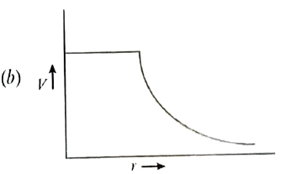
distance (r) form the centre as:
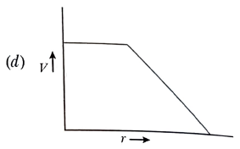
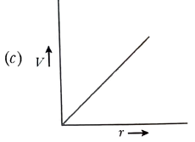
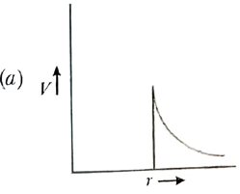

(iv) The work done in carrying a charge Q once round a circle of radius r with a charge q at the centre of the circle is;

(v) At a point A, there is an electric field of 500 V/m and potential difference of 3000 V. The distance between the point charge and A is:

(a) 6 m (b) 36 m (c) 12 m (d) 144 m

